**GENERAL INFORMATION**

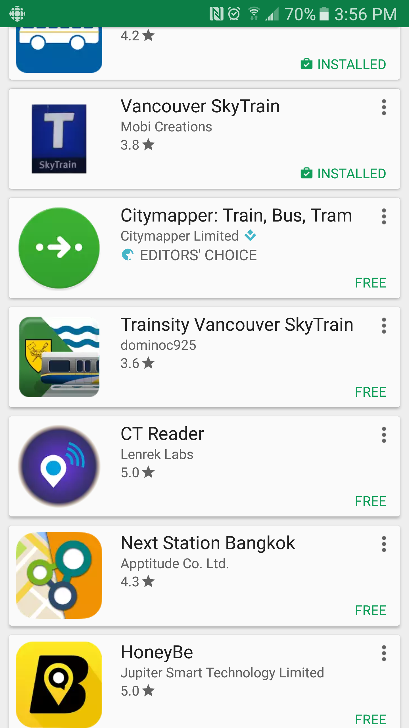

APP NAME: Vancouver Skytrain

VERSION: 1.01

DEVELOPER: Mobi Creations

LAST UPDATED: 2012 Jan 25

DOWNLOADS: 10000

PLAY STORE RATING: 3.8 of 39

Vancouver SkyTrain App provides shortest path (number of stations) and its trip time, fare (regular and special)

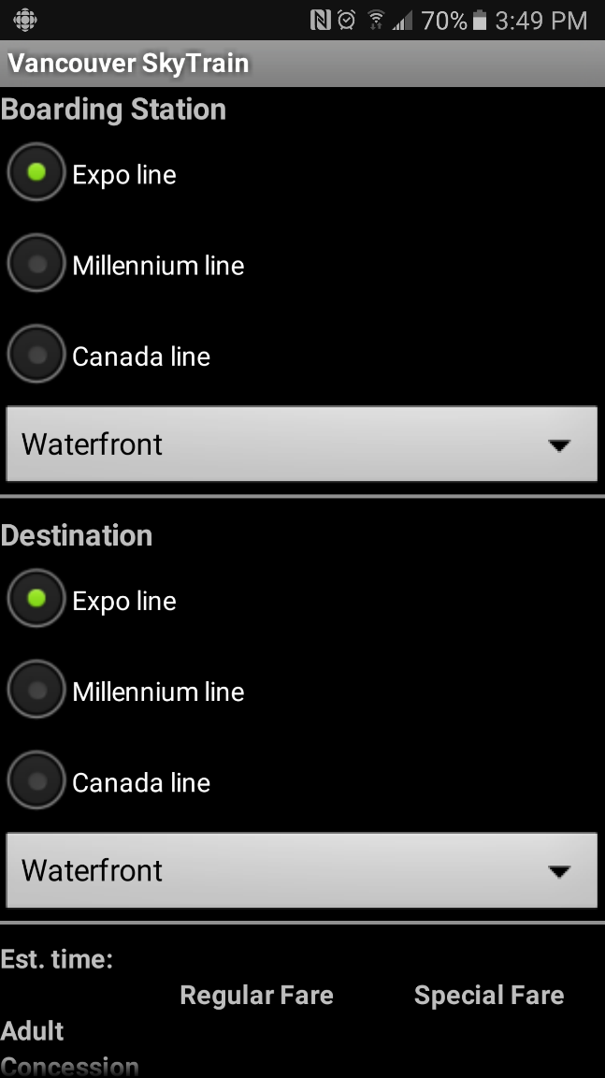

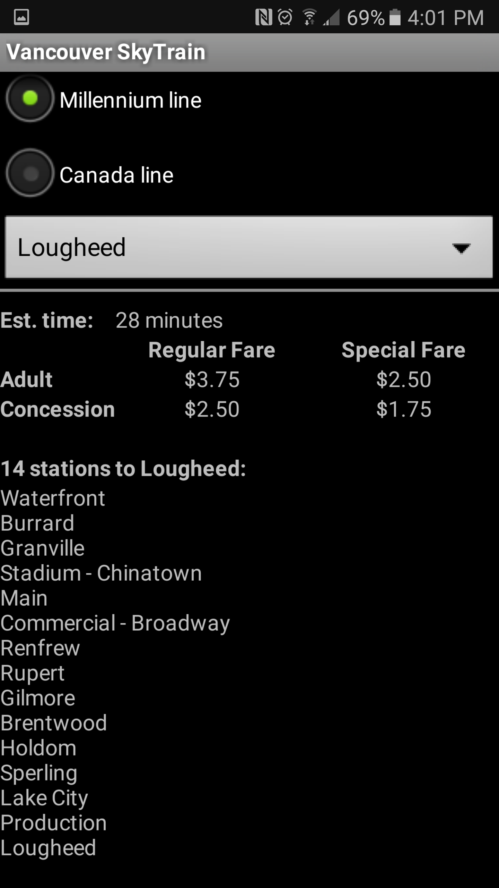

Basic GUI structure Result information

**Usability (35)**

Vancouver SkyTrain App has very clear structure to understand how to use it. User just needs to select boarding station and destination station. The app automatically shows the information without click any button.

However, when user select one of stations, user have to select SkyTrain line (Expo, Millennium, Canada) first, that means user need to know which station belongs to a certain line. But it doesn’t support search station feature so that users can feel difficulties to select their target stations.

It’s quite light and doesn’t need network or GPS signal. Therefore, users having no enough data or battery also can use it conveniently.

Station path result doesn’t mark the transit point or line changing information. User might pass the transit point and get lost. It should have been shown at least by different color of station name

**Responsiveness (20)**

This app provides users with only very simple information and there is no additional information requiring network or GPS signal. Therefore, it’s fast and couldn’t feel any processing time to show the results.

**Aesthetics (20)**

It has just black background and white characters. There are radio buttons to select SkyTrain line, dropdown list to select station which is string type information.

It doesn’t use any color or icons which is matching with TransLink, SkyTrain, or its line. For example, TransLink mostly use blue and yellow color, and each line has its unique color (Millennium: yellow, Expo: blue, Canada: sky-blue). This makes user more difficult to search station and track their journey.

It managed to be called a graphical user interface and I couldn’t find any efforts to make it looks better.

**Support (15)**

This app is not updated recently (the latest update is in 2012) and fare information is out of date (1 zone shows 2.5 which is actually 2.75, 2 zone as 3.75 which is 4, and 3 zone as 5 which is 5.5). This app was updated just once after initial release. It seems like being neglected now.

Obviously, Evergreen line does not exist

**Additional Features (10)**

Estimation time could be mentioned as an additional feature.

**Final Conclusions**

Vancouver SkyTrain app is good for travellers who just want to know about SkyTrain route without network or data consumption. It has light and straightforward user interface so that it’s easy to use without any adopting period. – This point could work for old generation or people who can’t handle smart devices well. However, it’s not decent to figure out user’s journey because it doesn’t show map (including SkyTrain route map) and transit point neither. Even worse, it doesn’t provide any graphical or colored clue to assume which station belongs to a certain line. Due to the lack of update, its fare information is not correct and there is no Evergreen line station (Even though the fact that official TransLink web page also still has no information on Evergreen line).

|  |  |  |
| --- | --- | --- |
| Criteria | Weight | Score |
| Usability: | 35 | 25 |
| Aesthetics: | 20 | 3 |
| Responsiveness: | 20 | 20 |
| Additional Features: | 10 | 3 |
| Support: | 15 | 3 |
| Total: | 100 | 54 |